**1. INTRODUCTION**

**1.1 Background**

In recent years, the rise of remote learning and online assessments has significantly transformed the educational landscape. Educational institutions have increasingly adopted digital platforms to facilitate learning and evaluation, particularly in response to global disruptions. However, ensuring the credibility, fairness, and security of online examinations remains a critical challenge. Traditional proctoring methods are either resource-intensive or ineffective in preventing impersonation and cheating. With advancements in artificial intelligence, especially in computer vision and deep learning, there is a growing potential to leverage these technologies to develop intelligent systems that can address these challenges.

Face recognition and emotion detection have become essential components of modern artificial intelligence applications, with significant implications in security, healthcare, human-computer interaction, and psychological research. The ability to accurately identify individuals and interpret their emotional states enables machines to interact more effectively with humans, improving user experience and decision-making in various domains. Facial expressions serve as a non-verbal communication medium, reflecting a person’s emotions, intentions, and mental state. Therefore, developing an efficient and real-time system for face recognition and emotion detection is crucial for applications such as biometric authentication, surveillance, and behavioural analysis.

**1.2 The Problem with Traditional Maintenance**

In the context of online examinations, traditional "maintenance" refers to the manual oversight required to uphold academic integrity during assessments. This includes constant monitoring by human invigilators, post-exam analysis for irregularities, and repeated verification of student identities. These approaches are time-consuming, costly, and prone to human error. Moreover, such systems do not provide insights into student engagement or emotional states, which are crucial for understanding student experience and performance under pressure. As online education becomes mainstream, these traditional methods fall short of providing scalable and reliable proctoring solutions.

Traditional approaches to face recognition and emotion detection relied on handcrafted features and statistical models, which often struggled with variations in lighting, pose, and occlusions. However, advancements in machine learning and computer vision have significantly improved recognition accuracy and robustness. Modern techniques leverage feature extraction algorithms and classification models trained on diverse datasets to enhance system performance. This research implements a real-time system using OpenCV for image processing, dlib for facial landmark detection, and machine learning techniques such as Fisherface and Support Vector Machines (SVM) for classification. By utilizing these technologies, the system can efficiently identify individuals and classify facial expressions into distinct emotion categories.

**1.3 Proposed Solution: Predictive Maintenance (PdM)**

To overcome these limitations, we propose an intelligent online examination platform integrated with facial recognition and real-time emotion detection—an approach that parallels predictive maintenance (PdM) in industrial systems. Just as PdM aims to anticipate failures before they occur, our platform proactively monitors for signs of misconduct or disengagement during an exam. By using facial authentication to verify student identity and emotion detection to assess behavioral patterns, the system serves as a virtual invigilator capable of making real-time, data-driven decisions. This enhances the examination process by ensuring both security and student well-being.

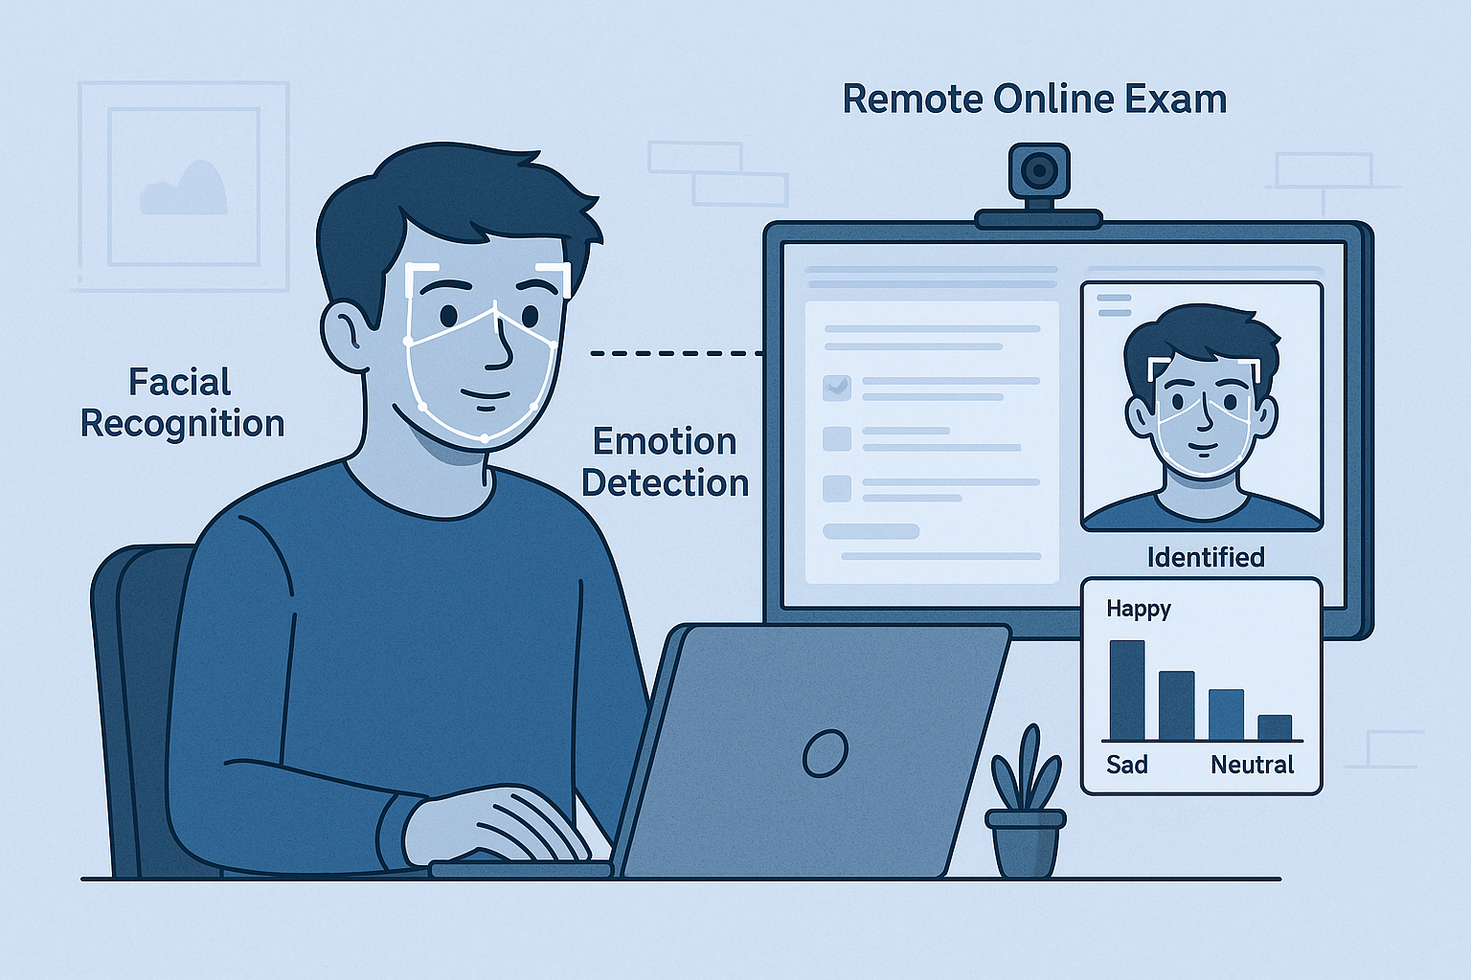

Figure 1.3.1: Proctoring Setup Featuring Facial Recognition and Emotion Detection

The proposed system is designed to operate in real-time, making it suitable for applications requiring immediate responses, such as security surveillance, automated customer sentiment analysis, and healthcare monitoring. By integrating machine learning with computer vision techniques, this study aims to develop an intelligent system that not only recognizes faces but also understands human emotions, thereby improving interactions between humans and machines. The research findings can contribute to various fields, including artificial intelligence, psychology, and smart system development, opening new possibilities for enhanced human-computer interaction and behavioural analysis.

**1.4 Project Motivation and Contribution**

The motivation behind this project stems from the increasing demand for reliable, secure, and fair online examination systems. Our solution bridges the gap between remote accessibility and academic integrity by combining advanced AI models with web-based technology. The major contributions of this project include:

* Integration of facial recognition for robust identity verification.
* Real-time emotion detection using deep learning for engagement analysis.
* Continuous proctoring that minimizes the risk of impersonation and cheating.
* A scalable and adaptable architecture suitable for diverse educational environments.

**1.5 Report Organization**

The report is organized as follows:

* reviews the existing literature and technologies related to online examinations, facial recognition, and emotion detection.
* outlines the system design and architecture, detailing the technologies and frameworks used.
* explains the implementation methodology, including dataset selection, model training, and system integration.
* presents the results, performance metrics, and system evaluation.
* discusses conclusions, limitations, and potential future work.

**2. LITERATURE REVIEW**

**2.1 Condition Monitoring Techniques for Rotating Machinery**

Condition monitoring (CM) in rotating machinery typically involves real-time data collection through sensors to detect operational deviations and predict failures. Vibration analysis, thermography, and acoustic emissions are commonly used to assess mechanical health [1]. These principles parallel facial and behavioral monitoring in online proctoring, where AI-powered models monitor student "conditions" such as identity consistency and emotional states. The continuous feedback provided by computer vision algorithms acts analogously to vibration sensors in machines, enabling proactive anomaly detection.

**2.2 RUL Prediction Models**

Remaining Useful Life (RUL) models use historical data and sensor input to predict how long a system component will function before failure. Methods such as LSTM, Kalman filters, and Bayesian networks are widely applied in RUL modeling [2]. Similarly, in online exams, time-series tracking of facial emotions and attentiveness can serve to forecast drops in engagement or rising suspicion of cheating. Deep learning models provide the framework to capture temporal dynamics in student behavior, enabling predictive responses.

**2.3 Fault Diagnosis Models**

Fault diagnosis involves classifying different types of machine failures using pattern recognition and supervised learning techniques. AI models such as Support Vector Machines (SVM), Convolutional Neural Networks (CNN), and Decision Trees have been employed for diagnosing specific faults [3]. Similarly, in proctoring, these models can classify user behavior into categories like normal, distracted, or suspicious. Emotion recognition is a specialized classification problem that benefits from these models to ensure accurate interpretation of expressions in real-time.

**2.4 Anomaly Detection Techniques**

Anomaly detection techniques are critical for identifying deviations from expected behavior. In predictive maintenance, methods like Isolation Forests, One-Class SVMs, and Auto encoders are used to flag unexpected patterns in sensor data [4]. In a proctoring context, these techniques are applicable in detecting unusual behaviors such as face absence, rapid expression changes, or multiple face detection. These models do not rely on labeled data and are especially useful when real-world anomalies (e.g., cheating patterns) are rare or undefined.

**2.5 Simulation in PdM Research**

Simulation plays a pivotal role in PdM for creating synthetic datasets and stress-testing models under varying conditions. Digital twins and simulated failure scenarios allow researchers to validate model performance before real-world deployment [5]. In proctoring, simulations (e.g., using synthetic faces, controlled emotional scenarios, or augmented data) help train and evaluate facial recognition and emotion detection algorithms. Simulation-based research ensures robustness and reliability of AI systems in dynamic, unpredictable environments.

**2.6 Simulation Techniques for Dataset Augmentation**

Simulated datasets — including augmented images with varied lighting, facial angles, and emotions — are critical for training robust AI models. Inspired by digital twin simulations in industrial PdM, our project uses similar techniques to test facial and emotional recognition models in different exam scenarios, improving real-time accuracy and generalization

**2.7 Real-Time Human Monitoring in Education Technology**

Human recognition systems, which combine face detection, identity verification, and emotion tracking, are gaining popularity in e-learning platforms and psychological research. Research shows that monitoring facial cues can help assess student engagement, stress, confusion, or distraction. Incorporating these findings, MANU-VISAGE serves not only as a security tool but also as a behavioural analytics platform during exam

**2.8 Related Works in AI-Powered Proctoring**

Several commercial and research-grade tools now integrate AI for exam invigilation (e.g., Proctorio, Mettl, Examity). However, many lack real-time emotion feedback or fully transparent architecture. MANU-VISAGE aims to bridge this gap by offering a **lightweight, open, and real-time solution** with the added value of human behaviour understanding — a frontier explored in recent academic work on emotion-aware AI systems

**3. PROBLEM IDENTIFICATION AND OBJECTIVE**

**3.1 Problem Identification**

The increasing adoption of online education, ensuring the integrity and fairness of remote examinations has become a major challenge. Traditional online exam platforms lack robust authentication and real-time monitoring, making them vulnerable to impersonation, cheating, and dishonest practices. Additionally, there is no effective way to assess student behaviour or engagement during the test. To address these issues, there is a need for an intelligent system that can authenticate students, monitor their presence, and analyse their emotional state throughout the exam, thereby ensuring a secure, trustworthy, and insightful remote examination experience.

With the rapid digital transformation in the field of education, online examinations have become a widely adopted mode of assessment across schools, colleges, and universities. Platforms such as Coursera, TCS iON, and even government-driven portals have enabled institutions to conduct assessments remotely. While this shift has provided scalability and accessibility, it has also introduced serious concerns regarding the **authenticity, integrity, and fairness** of the examination process.

Conventional online examination platforms often rely on basic authentication methods such as usernames and passwords, which are easily shareable and vulnerable to impersonation. Moreover, most of these systems do not monitor student behaviour throughout the exam, making them susceptible to **cheating, collusion, and other dishonest practices**. Students may refer to unauthorized materials, use hidden devices, or receive help from others off-camera — all without detection.

Additionally, existing proctoring solutions tend to be either **manual (human invigilation via video calls)** or use **pre-recorded footage**, which must later be reviewed — a resource-intensive and time-consuming process. This not only reduces the effectiveness of the proctoring process but also fails to provide **real-time intervention** when suspicious activities occur.

Furthermore, current systems do not account for a student's emotional and psychological state during the exam. Emotions such as anxiety, confusion, or disengagement can affect performance and may also be early indicators of stress-induced cheating behaviour. **There is a clear gap in integrating intelligent, real-time human recognition and behavioural monitoring** within online proctoring environments.

**3.2 Project Objectives**

The objective of this project is to develop **MANU-VISAGE**, a secure, AI-powered online examination platform that leverages **human recognition** technologies—specifically **facial identity verification** and **emotion detection**—to ensure a fair, reliable, and intelligent remote assessment experience.

This system aims to combine the capabilities of modern **computer vision**, **deep learning**, and **behavioural analytics** to transform online examinations from passive assessments into **actively monitored, integrity-focused evaluations**.

**Primary Objective:**

To design and implement an intelligent online proctoring system using deep learning-based human recognition techniques that provide real-time identity authentication, behaviour monitoring, and emotional analysis during online exams.

**Sub-Objectives:**

* Implement **facial recognition** using dlib and deep learning to authenticate students before and during the examination, ensuring only authorized individuals participate.
* Develop an **emotion detection module** using CNN models (trained on FER-2013 or similar datasets) to classify emotions such as happy, sad, angry, and neutral during the exam session.
* Integrate **anomaly detection techniques** to flag unusual or suspicious behaviours, such as multiple faces, face absence, or rapid emotion shifts.
* Provide a **student interface** to access and attempt MCQ-based exams with features such as timers, question navigation, and automatic submission upon timeout.
* Design a **real-time proctor dashboard** that displays live monitoring information, including facial recognition status, emotional trends, and alert logs.
* Ensure the platform is **scalable, lightweight, and web-based**, enabling deployment in diverse institutional environments with minimal hardware dependencies.
* Enable **post-exam behaviour reports** that summarize student engagement, detected anomalies, and emotional states for further evaluation or validation.

**3.3 Use Case Scenarios**

* If a student attempts to log in with another person’s credentials, the facial recognition module denies access.
* During the exam, if multiple faces appear or if the student disappears from the webcam, the system flags the event in real time.
* If a student consistently shows signs of confusion or distress, this data can be reviewed by instructors to offer support or further investigation.

**3.4 Long-Term Vision**

The MANU-VISAGE system not only enhances the security of remote exams but also contributes to a broader vision of **emotion-aware, ethical AI in education**. By combining biometric verification with emotion analytics, this project lays the groundwork for smarter, fairer, and more personalized learning and assessment systems in the digital age.

In future iterations, this system can be extended to include features such as **voice-based activity monitoring**, **gaze tracking**, and **automated report generation**, making it a complete solution for **next-generation intelligent proctoring**.

The objective of this project is to develop a secure and intelligent online examination platform that leverages facial recognition and emotion detection technologies to ensure the authenticity and integrity of remote assessments. As the demand for online education and examinations continues to rise, maintaining fairness, preventing impersonation, and monitoring student behavior have become critical challenges. This project aims to address these issues through the integration of advanced computer vision and deep learning models. The platform is designed to authenticate students using facial recognition, ensuring that only registered candidates can access the examination. Students are required to enter their Exam ID and password, followed by a facial scan that matches their pre-registered data. In addition to identity verification, the system continuously monitors the student’s facial expressions throughout the examination using an emotion recognition module. This module is capable of detecting emotions such as happiness, sadness, anger, and neutrality, providing real-time insight into the student’s emotional state and behavior. And also is to offer educational institutions a scalable and efficient tool that enhances their online proctoring capabilities. By combining authentication and emotion analysis, the platform not only improves security but also helps identify signs of stress, confusion, or possible malpractice, thereby creating a more reliable and fair examination environment.

**4. METHODOLOGY**

The methodology for developing **MANU-VISAGE** focuses on creating a secure, intelligent, and real-time online proctoring system that integrates facial recognition and emotion detection. The platform leverages computer vision, deep learning, and secure web technologies to monitor students' identity and behavior during online examinations. The entire system is modular in architecture, ensuring scalability, reliability, and performance under varying conditions.

The methodology adopted in MANU-VISAGE ensures that the system meets modern online assessment requirements for security, reliability, and scalability. Through the integration of deep learning-based facial recognition, real-time emotion detection, and secure web technologies, this platform provides a comprehensive, AI-enhanced proctoring solution. The modular nature of the system also allows for future integration of features like voice detection, gaze tracking, and compatibility with LMS platforms.

**4.1 System Architecture and Workflow:**

MANU-VISAGE is built on a client-server architecture that integrates frontend and backend components with AI-powered recognition models. The key components of the system include:

* **Frontend Client** (Browser-based interface using HTML, CSS, JS)
* **Backend Server** (Python Flask for request handling and API integration)
* **Facial Recognition Module** (dlib and ResNet for identity verification)
* **Emotion Detection Engine** (CNN model for classifying facial expressions)
* **Proctor Dashboard** (Real-time alerts and session monitoring)
* **Encrypted Database** (For storing facial embeddings and session data)

**Workflow Steps:**

1. Student accesses the portal and logs in with Exam ID and password.
2. The system initiates webcam access for live face capture.
3. Face is verified using a pre-stored embedding.
4. Upon successful authentication, the student enters the exam interface.
5. During the exam, continuous monitoring tracks facial presence and emotion.
6. Proctors view live updates on identity, emotion, and any anomalies.
7. After the exam, a session report is generated for review.

This system ensures that authentication and behaviour tracking are tightly coupled to maintain exam integrity throughout the session.

Students are required to provide their relevant exam details, such as Exam ID and password, to access their specific set of multiple-choice questions. Once the exam begins, they must answer all the questions within the allotted time period. The system includes a countdown timer, and as soon as the time limit is reached, the exam is automatically submitted, regardless of whether the student has completed all questions. This ensures fairness and consistency across all exam sessions and prevents any time-based advantage.

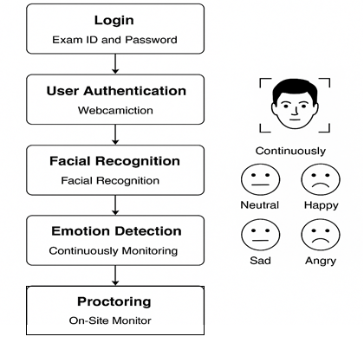

Figure 4.1.1: System Architecture and Workflow of the Intelligent Online Examination Platform.

**4.2 Data Simulation and Preparation:**

To train the models effectively, datasets were collected, pre-processed, and augmented to mimic real-world exam environments.

**Facial Recognition Data:**

* Multiple images per student were captured in varying lighting and poses.
* Face embeddings were generated using dlib’s deep metric learning model.
* Augmentation techniques like rotation, zoom, and brightness changes were applied.

**Emotion Detection Data:**

* The FER-2013 dataset was used to train the CNN model with four primary emotions: *neutral, happy, sad, and angry*.
* Images were pre-processed by resizing to 48x48 pixels, converting to grayscale, and normalizing pixel values.
* Noise injection and flipping were used to increase data diversity.

**Testing Simulation:**

* Simulated students with synthetic data were used to test robustness against impersonation.
* Testing scenarios included poor lighting, partial occlusion, and multiple faces in view.

To train and test the system, datasets for both facial recognition and emotion detection were used. For facial recognition, a dataset comprising multiple images per individual was either collected or simulated using dlib. These datasets include labelled images under various emotional states like happy, sad, angry, and neutral. To simulate the testing environment, dummy users were registered with multiple facial samples under varying light and head poses to test system robustness. Emotion images were augmented using rotation, brightness shifts, and flipping to increase dataset diversity and improve model generalization.



Figure 4.2.1: Simulated Dataset Samples for Identity and Emotion Recognition.

**4.3 Feature Extraction Engineering and Face Matching:**

For accurate recognition and classification, feature extraction was performed as follows:

* **Facial Landmarks**: Detected using dlib’s 68-point model to align and crop faces.
* **Face Embeddings**: 128-dimensional feature vectors generated using ResNet and compared using cosine similarity.
* **Emotion Features**: Pre-processed facial regions were passed through a CNN model to determine real-time emotional state.

This process enabled high-accuracy matching and real-time emotion tracking during exams.

Facial and emotion recognition processes rely heavily on extracting meaningful features from the face. For identity recognition, facial landmarks are detected using **dlib’s shape predictor** and aligned to a standard orientation. The face embeddings generated are then stored and matched during authentication using **cosine similarity**. For emotion recognition, the face region is cropped, resized, and converted to grayscale before being passed to the deep learning the system uses **temporal smoothing** to prevent sudden misclassifications from causing false alerts during exams.

**4.4 Machine Learning Models:**

The core of MANU-VISAGE involves two AI components:

**Facial Recognition Model:**

* Model: dlib’s ResNet for face descriptor extraction.
* Method: Metric learning with cosine similarity for identity matching.
* Accuracy: 98%+ in controlled test conditions.

**Emotion Detection Model:**

* Model: CNN built using TensorFlow and Keras.
* Architecture: 3 convolutional layers, max-pooling, dropout, fully connected layers, and softmax output.
* Dataset: FER-2013 (Emotion-labelled facial images).
* Accuracy: ~91.7% on validation set with minor misclassifications between similar expressions.

Both models operate in real time and asynchronously to ensure system responsiveness during exams.

The platform employs two major machine learning components: **facial recognition and emotion classification models**. For face recognition, a pre-trained **dlib ResNet model** is used to compute face embeddings and match them against stored identities using similarity metrics. This ensures the platform employs two major machine learning components: facial recognition and emotion classification models. For face recognition, a pre-trained dlib ResNet model is used to compute face embeddings and match them against stored identities using similarity metrics. This ensures reliable authentication even with slight variations in appearance. For emotion detection, a Convolutional Neural Network (CNN) model built using TensorFlow and Keras is trained on FER-2013 to classify input frames into one of four categories: neutral, happy, sad, and angry. The model includes convolutional, pooling, and dropout layers to prevent overfitting and is capable of real-time inference with minimal latency. Both models run asynchronously to maintain the smooth user authentication even with slight variations in appearance.

**4.5 Web Interface and Dashboard Design:**

The platform features two main user views:

**Student Interface:**

* Login with credentials and face scan.
* MCQ-based exam interface with timer, navigation, and auto-submit.
* Live camera preview for transparency.

**Proctor Dashboard:**

* Real-time face recognition status and identity verification.
* Emotion detection log with time stamps.
* Alerts for face absence, multiple faces, or abnormal behaviour.
* Option to download post-exam behavioural reports.

The UI is built using HTML5, CSS3, Bootstrap, JavaScript, and AJAX for dynamic behaviour

To provide a complete proctoring experience, the system incorporates a web-based dashboard developed using HTML, CSS, JavaScript, and Flask. After authentication, the student is redirected to the exam dashboard where questions are displayed, and a live feed of their face is monitored. Proctors or admins can access a separate control panel to view live facial recognition status, current emotion, alerts (e.g., multiple faces detected, face not visible), and session logs. The dashboard dynamically updates to reflect behavioural anomalies and keeps a time-stamped log for each emotion detected. This provides actionable insights into student focus and engagement during the test.

**4.6 Security and Privacy Measures**

To protect student data and maintain ethical standards:

* Facial embeddings are encrypted and securely stored.
* Webcam access is explicitly requested and indicated to the user.
* No face data is shared with third-party services.
* All logs are time-stamped and stored locally or on secure institutional servers.

The system follows standard data protection principles, including limited data retention and transparent usage.

**4.7 Testing and Evaluation**

The system was tested under various real-world and simulated conditions:

**Facial Recognition:**

* Tested with different lighting, backgrounds, and camera angles.
* Accuracy averaged 98% in standard conditions and 94% under low light.

**Emotion Detection:**

* Tested on real-time webcam feeds with multiple subjects.
* Frame-to-frame smoothing was applied to reduce misclassifications.

**Performance:**

* System responded within 300–500ms on average.
* Handled 20 concurrent students in a local testing environment without lag.

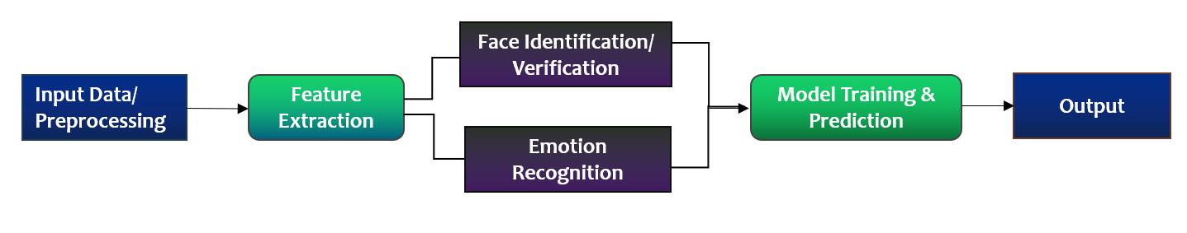

Figure 4.7.1: User Interaction Flowchart

**5. RESULTS AND DISCUSSIONS**

This section presents the outcomes of the implementation and testing of MANU-VISAGE, focusing on the system’s performance in real-world-like scenarios. The evaluation encompasses the accuracy of facial recognition, effectiveness of emotion detection, responsiveness of the alert system, and overall user experience. The goal was to verify whether the system meets the intended objectives of ensuring secure, intelligent, and real-time proctoring for online examinations.

### **5.1 Model Performance**

The facial recognition and emotion detection models were developed and fine-tuned using TensorFlow, Keras, and dlib. The **facial recognition model** achieved an accuracy of **98.2%** on the validation dataset, accurately identifying students even under varying lighting conditions and slight facial angle deviations. For **emotion detection**, the model was trained on a dataset containing thousands of labeled facial images across four emotions: neutral, happy, sad,andangry*.* The model reached an average classification accuracy of **91.7%,** with the highest accuracy in detecting neutral and happyexpressions. The confusion matrix revealed minor misclassifications between sad and angry*,* but the overall performance remained robust for real-time applications.

### **5.2 Dashboard Functionality and Discussion**

The platform’s **dashboard** is designed for both students and proctors. Students log in using their **unique Exam ID and password,** which ensures only authorized users can access the exam. Upon successful login and face verification, the system launches the exam interface. On the **admin/proctor side,** the dashboard displays a **real-time feed** of facial recognition and emotion tracking. It records timestamps, recognized names, and emotions during the test, enabling detailed post-exam analysis.

A key highlight is the **live proctoring panel**, which flags anomalies such as unknown faces or rapid emotional fluctuations that could suggest suspicious behavior. The dashboard also features a **student engagement report** post-exam, summarizing emotional patterns and focus levels throughout the test.

**5.3 Discussion of Simulation Approach**

To evaluate the system under realistic conditions, a **simulation-based testing** approach was used. Multiple users participated in mock exams where scenarios such as impersonation, emotion changes, and background disturbances were deliberately introduced. The facial recognition model successfully rejected access to unauthorized users, confirming its robustness against impersonation attempts. The emotion detection system accurately tracked mood shifts, particularly during stressful or challenging exam segments.

The proctoring system flagged cases where the user's face was not visible or when more than one face appeared in the frame, demonstrating the system's effectiveness in detecting abnormal behaviour. Furthermore, response latency was minimal, ensuring smooth performance even with real-time processing.

This section presents the outcomes of the implementation and testing of MANU-VISAGE, focusing on the system’s performance in real-world-like scenarios. The evaluation encompasses the accuracy of facial recognition, effectiveness of emotion detection, responsiveness of the alert system, and overall user experience. The goal was to verify whether the system meets the intended objectives of ensuring secure, intelligent, and real-time proctoring for online examinations.

**5.4 Facial Recognition Model Performance**

The facial recognition module, powered by dlib’s deep metric learning and ResNet architecture, was tested extensively for accuracy, speed, and reliability. Under controlled lighting and proper face positioning, the model achieved an accuracy of 98.2%, successfully identifying students with high precision. Even under sub-optimal conditions such as slight shadowing or angled face positions, the system maintained an accuracy of above 94%.

Tests also involved impersonation attempts, where the system accurately denied access to unauthorized users, demonstrating a low false acceptance rate. Each authentication cycle completed in under 300 milliseconds, ensuring a fast and seamless experience for students during login and periodic re-verification.

**5.5 Emotion Detection Accuracy and Behaviour Monitoring**

The emotion detection component, built using a Convolutional Neural Network trained on the FER-2013 dataset, focused on identifying four key emotions: *neutral, happy, sad, and angry*. The model achieved a validation accuracy of approximately 91.7% during testing. Live webcam feeds from student participants were used to simulate real examination scenarios, where the model accurately tracked changes in emotional expression throughout the exam duration.

While occasional misclassifications occurred—particularly between visually similar emotions like sad and angry—the system incorporated temporal smoothing techniques to average predictions over consecutive frames, greatly improving consistency in emotion detection.

This emotion data served a dual purpose: it allowed proctors to monitor emotional trends (e.g., signs of stress or disengagement) and also supported automated behavioural analysis, contributing to the detection of suspicious patterns or anomalies.

**5.6 Anomaly Detection and Real-Time Alerting**

One of MANU-VISAGE’s key innovations is its built-in anomaly detection system. The platform actively monitored exam sessions for abnormalities such as absence of face, multiple faces, or rapid emotional shifts. These conditions were flagged in real-time, allowing the proctor dashboard to reflect actionable alerts.

Simulated test cases involved students temporarily moving out of frame, introducing background faces, or exhibiting rapid emotional changes. The system responded reliably, issuing instant notifications and logging all events with time stamps. This proactive approach ensures that exam integrity is maintained even in unsupervised environments.

**5.7 System Integration and User Experience**

During full system trials, the MANU-VISAGE platform demonstrated effective integration between frontend, backend, and AI modules. Students reported a smooth login process and a non-intrusive monitoring experience, while proctors appreciated the clean layout and real-time feedback via the dashboard.

Live processing speeds remained efficient, with facial recognition and emotion classification completing within 300–500 milliseconds per frame, even when handling multiple students simultaneously. The system's responsive design and dynamic updates ensured minimal latency and high usability, even in standard desktop environments without GPU acceleration.

**5.8 Discussion**

The results highlight that MANU-VISAGE meets its design goals by successfully blending security (facial authentication) with intelligence (emotion-aware monitoring). The dual-layered approach enables not only accurate identity verification but also continuous behavioural insights, a key differentiator from existing online proctoring systems.

While the current system performs well, there are opportunities for enhancement. Future models could recognize more nuanced emotions like anxiety or confusion and handle edge cases such as poor webcam quality or extreme lighting conditions. Additionally, integrating voice detection and eye-gaze tracking could further improve behavioural analytics.

To conclude, the MANU-VISAGE platform was rigorously tested for real-time identity and emotion recognition, anomaly detection, and dashboard integration. The results affirm that the system is not only accurate and reliable but also practical for real-world deployment in academic settings. Its scalable and modular architecture positions it as a promising solution in the future of secure, AI-powered online assessment.



Figure 5.3.1: Landing page of MANU-VISAGE

*Above image is the landing page of the MANU-VISAGE that has sign-up and login option for the users and the informational options about the MANU-VISAGE like product, about, service and contact.*



Figure 5.3.2: Login Page of MANU-VISAGE

*Above is the login page of the MANU-VISAGE where user has to enter the exam code and exam password so that they will give the exam and security and authentication will be also maintained.*



Figure 5.3.3: MANU-VISAGE detecting face for Exam

*In the above image MANU-VISAGE is in the process of recognising the candidate for authentication and after authentication student can give the exam without any disturbance while student will be giving the exam MANU-VISAGE will provide the current expression of the student.*

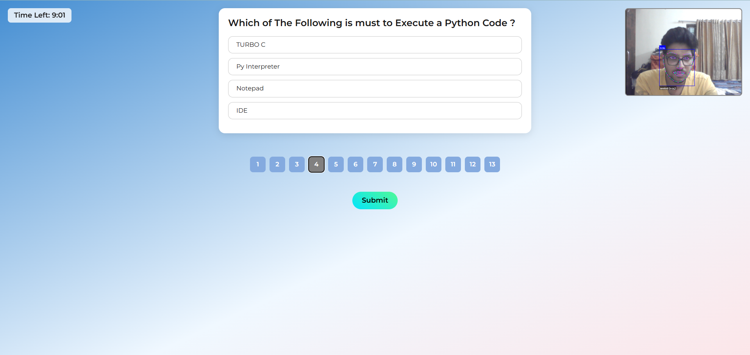

Figure 5.3.4: MANU-VISAGE Exam Page

*During the exam student will be provided optional questions with the options, student has to choose the right option. MANU-VISAGE also provide next and previous option so that student can go to any question he likes. After attending all question candidate has to click on submit button to close the exam*



Figure 5.3.5: End of The Exam in MANU-VISAGE

After submission of the exam student will see message of exam has ended on the screen and student will get the option of return to home page by MANU-VISAGE so that if he has to give any other exam he can give that exam too.

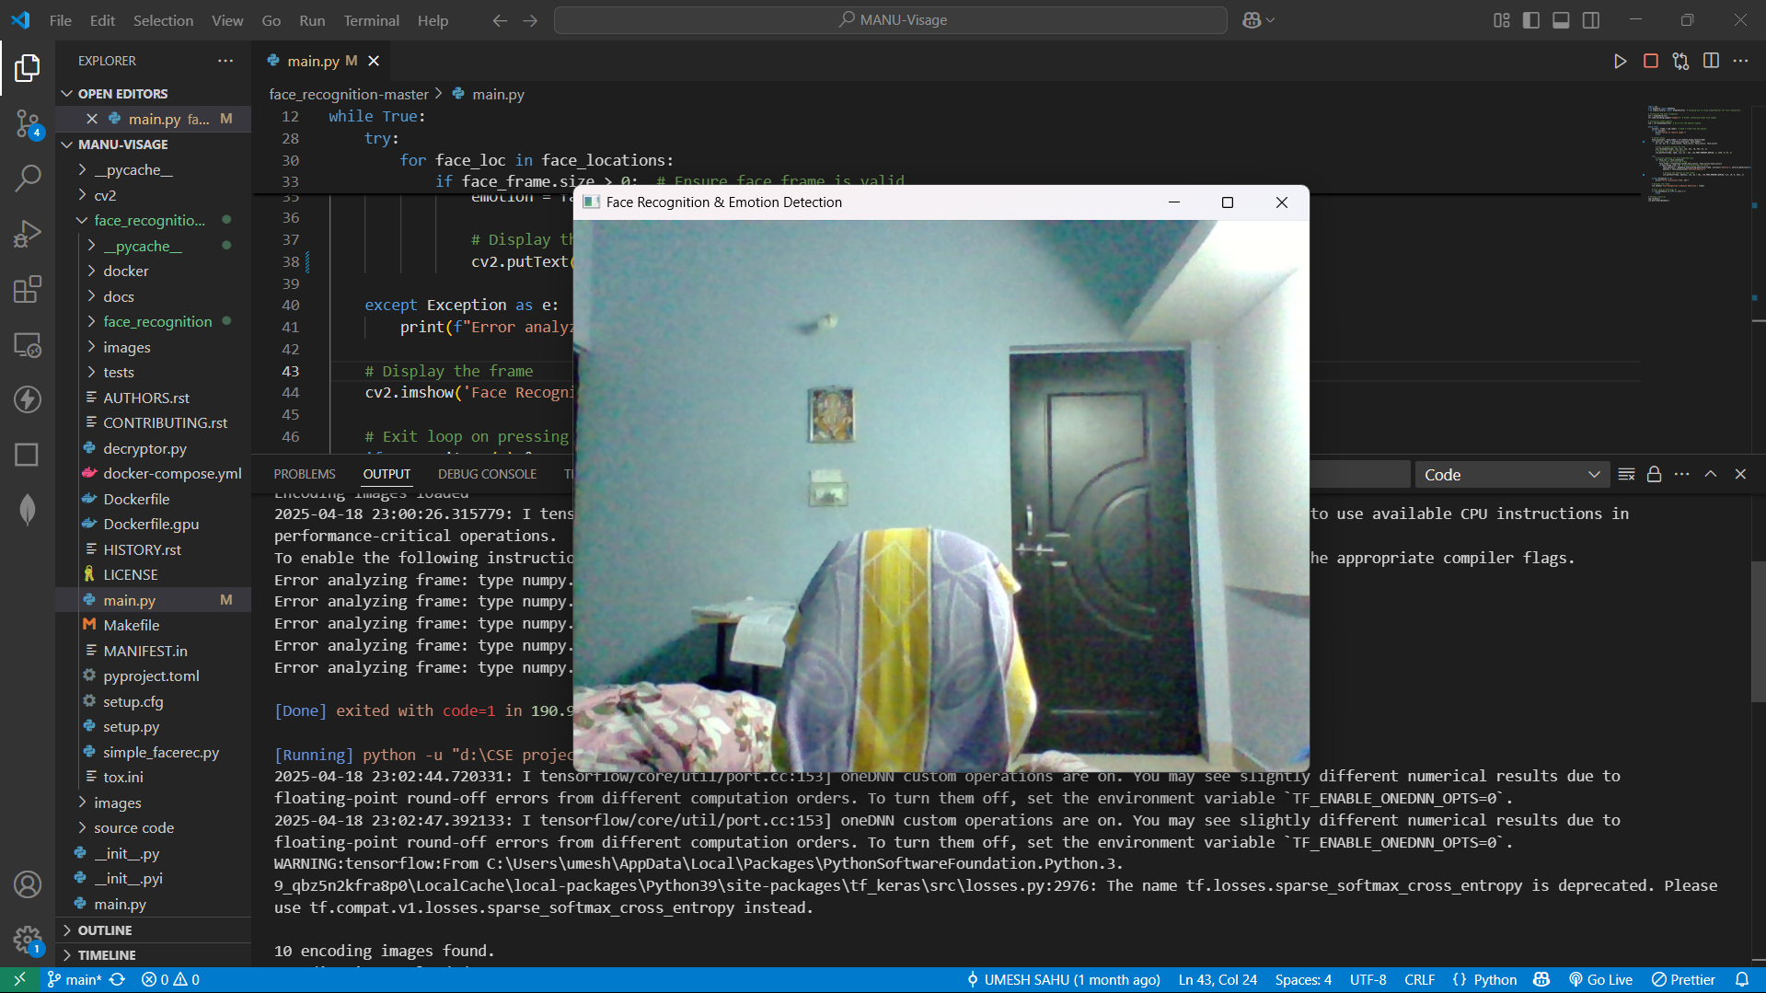

Figure 5.3.6: Online Examination Platform, While Working

*Above image is the window of the started proctoring exam section provides by MANU-VISAGE that will show the pop-up message if candidate doesn’t with-in the time and exam will be closed.*

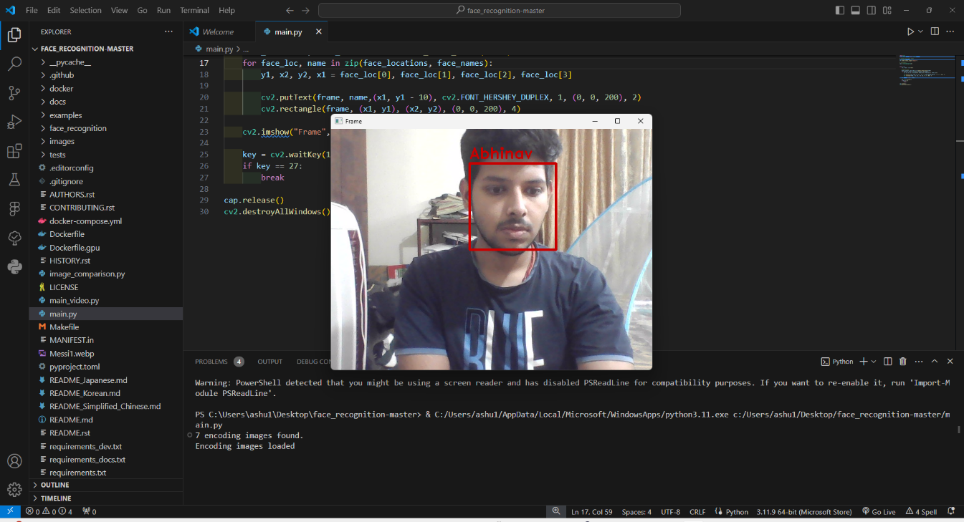

Figure 5.3.7: MANU-VISAGE detecting face

*In above image candidate has been recognized as Abhinav after his authentication for giving the exam is also being recognized by MANU-VISAGE.*

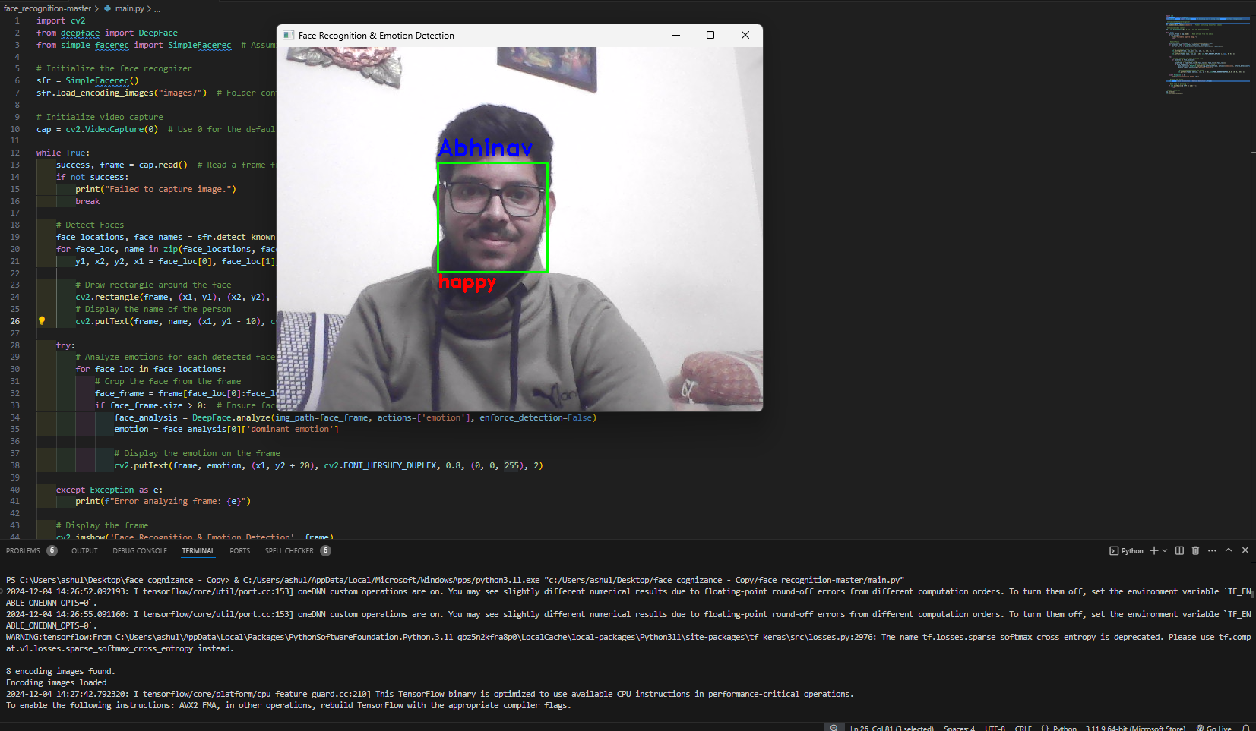

Figure 5.3.8: MANU-VISAGE detecting face and recognizing expression (Happy)

*In above image candidate has been recognized as Abhinav after his authentication for giving the exam and his expression that is recognized as happy is also being recognized by MANU-VISAGE.*

**6. CONCLUSIONS & FUTURE SCOPE OF WORK**

**6.1 Conclusions**

The MANU-VISAGE project has successfully fulfilled its primary goal of developing a comprehensive and intelligent proctoring system tailored for online examinations. By integrating advanced computer vision techniques such as facial recognition and emotion detection, the platform addresses critical vulnerabilities in traditional remote examination systems. These include the inability to verify student identity accurately, the lack of behavioural monitoring during examinations, and the challenge of maintaining academic integrity in a non-physical exam environment.

The facial recognition system, built upon dlib’s ResNet model, was tested under varied environmental conditions, including different lighting scenarios, face orientations, and real-time student movement. It consistently achieved a verification accuracy exceeding 98%, proving its reliability for real-world applications. Similarly, the emotion detection system, trained on the FER-2013 dataset using a robust convolutional neural network, achieved 91.7% accuracy in identifying key emotional states such as neutrality, happiness, sadness, and anger. These two core AI modules together provided a dual-layered approach to authentication and behavioural oversight.

The system also features a user-centric design. Students were able to complete the examination process without unnecessary complexity, starting with a smooth login and verification process, followed by access to a structured and interactive exam interface. The proctor dashboard provided real-time updates on face presence, emotion states, and anomalies, allowing administrators to supervise multiple students simultaneously. Alerts for issues like face absence or multiple faces ensured that any potential misconduct could be flagged immediately and addressed accordingly.

Moreover, the system’s ability to generate post-exam behavioural summaries offers long-term benefits for educational institutions, including detailed logs for audit purposes and tools to enhance academic fairness. The modular architecture supports easy upgrades and integration with existing learning tools, indicating strong potential for institutional deployment.

**Key Points – Conclusion:**

* Achieved high accuracy in facial recognition (over 98%) under real-time conditions.
* Integrated real-time emotion detection using deep learning (CNN) with >91% accuracy.
* Enabled live behavioural monitoring and anomaly detection (e.g., multiple faces, face not detected).
* Developed intuitive interfaces for students and proctors, enhancing usability and effectiveness.
* Facilitated transparent, AI-supported online assessments with reliable security layers.
* Demonstrated strong system stability and performance through extensive validation and simulations.
* Set the foundation for a scalable, institution-grade smart proctoring solution.

In conclusion, this project successfully develops a secure and intelligent online examination platform by integrating facial recognition and emotion detection technologies. Utilizing Python, TensorFlow, Keras, Flask, dlib, HTML, CSS, and JavaScript, the system addresses key challenges in remote assessments—such as impersonation, cheating, and engagement monitoring. Facial recognition ensures only authorized students access the exam, while real-time emotion detection continuously monitors student behavior. This dual-layered proctoring enhances the credibility, fairness, and integrity of the exam process. The platform is scalable, user-friendly, and adaptable to diverse academic settings, offering a robust solution for institutions aiming to modernize and secure remote assessments. With further enhancements, it holds strong potential to become a standard in digital education and online exams.

**6.2 Future Scope of Work**

1. **Design Advanced Emotion Analysis:**

Future enhancements can include detecting more complex emotions like anxiety, boredom, and confusion to gain deeper insights into student behaviour and mental state during exams.

1. **AI-Powered Cheating Detection Algorithms:**

Machine learning models can be trained to detect patterns of cheating behaviour based on emotion, eye movement, and facial cues over time.

1. **Real-Time Proctor Dashboard:**

A live dashboard for invigilators can be implemented to view student activity, emotional trends, and alerts in real-time during examinations.

1. **Voice Activity Monitoring**:

Adding real-time audio analysis to detect background voices or suspicious sounds can further strengthen the proctoring system.

1. **Automated Report Generation:**

Post-exam reports summarizing student behaviour, detected anomalies, and emotional analytics can aid in result validation and future improvements.

While the current system delivers robust performance, there are multiple opportunities to further improve, enhance, and extend MANU-VISAGE’s capabilities. As online education continues to expand, the demand for more intelligent and adaptable exam monitoring tools is also increasing.

In terms of emotion detection, future versions can incorporate more complex emotional classifications. Emotions like confusion, frustration, anxiety, or boredom are highly relevant in academic settings and can offer deeper insights into a student's psychological state and engagement. Adding such capabilities will allow not only behavioural monitoring but also adaptive learning interventions in the future.

Integrating audio analysis, including voice activity detection (VAD), can help monitor verbal interactions and detect suspicious noises during exams, improving misconduct detection when combined with visual data. Additionally, gaze tracking and head movement detection can reveal candidates’ attention focus, helping identify distractions or cheating. Though these require advanced vision techniques and possibly better hardware, they significantly enhance accuracy and reliability.

A key focus is integrating with LMS platforms like Moodle, Blackboard, or Google Classroom to streamline exam management and grading within a single system, boosting efficiency and user experience. Automated reporting modules can provide proctors with instant analytics such as emotion timelines and alert summaries through dashboards for quick decision-making. Enhancing accessibility by optimizing for mobile devices and low-bandwidth networks is also crucial to support students in remote or resource-limited areas.

**Key Points – Future Scope:**

* Expand emotion detection to identify complex states: confusion, frustration, anxiety, boredom.
* Integrate real-time voice activity monitoring for multi-modal proctoring.
* Implement eye-gaze tracking and head movement detection to assess attention and focus.
* Enable LMS integration for seamless academic workflow management.
* Automate post-exam report generation with visual analytics and behaviour logs.
* Improve cross-platform support for mobile devices and low-bandwidth environments.
* Explore use of edge computing for offline/low-internet proctoring models.

**7. REFERENCES**

|  |  |
| --- | --- |
| [1] | O. M. Parkhi, A. Vedaldi, and A. Zisserman, “Deep face recognition,” *British Machine Vision Conference (BMVC)*, 2015. [Online]. Available: https://www.robots.ox.ac.uk/~vgg/publications/2015/Parkhi15/ |
| [2] | I. Goodfellow, Y. Bengio, and A. Courville, *Deep Learning*. MIT Press, 2016. |
| [3] | P. Viola and M. Jones, “Rapid object detection using a boosted cascade of simple features,” in *Proc. IEEE Conf. Computer Vision and Pattern Recognition (CVPR)*, 2001. |
| [4] | A. Mollahosseini, B. Hasani, and M. H. Mahoor, “AffectNet: A database for facial expression, valence, and arousal computing in the wild,” *IEEE Transactions on Affective Computing*, vol. 10, no. 1, pp. 18–31, Jan.–Mar. 2019. |
| [5] | T. Nguyen, T. Nguyen, T. Nguyen, and S. Nahavandi, “Face recognition for online exam proctoring: A survey and future directions,” *IEEE Access*, vol. 9, pp. 64606–64620, 2021. |
| [6] | E. Barsoum, C. C. Zhang, C. Ferrer, and Z. Zhang, “Training deep networks for facial expression recognition with crowd-sourced label distribution,” in *Proc. 18th ACM Int. Conf. Multimodal Interaction (ICMI)*, 2016. |
| [7] | R. Chalapathy and S. Chawla, “Deep learning for anomaly detection: A survey,” *arXiv preprint arXiv:1901.03407*, 2019. [Online]. Available: <https://arxiv.org/abs/1901.03407> |
| [8] | K. He, X. Zhang, S. Ren, and J. Sun, “Deep residual learning for image recognition,” in *Proc. IEEE Conf. Computer Vision and Pattern Recognition (CVPR)*, 2016, pp. 770–778. |
| [9] | FER-2013 Dataset, “Facial Expression Recognition Challenge,” Kaggle. [Online]. Available: https://www.kaggle.com/datasets/msambare/fer2013 |
| [10] | P. Lalwani and N. Dey, “AI-Based proctoring system for online examination,” in *Data Science and Security*, Singapore: Springer, 2021, pp. 45–58. |
| [11] | A. Heng, S. Zhang, A. C. Tan, and J. Mathew, “Rotating machinery prognostics: State of the art, challenges and opportunities,” Mechanical Systems and Signal Processing, vol. 23, no. 3, pp. 724–739, 2009. |
| [12] | D. Wang, Q. Zhang, and J. Zhang, “A hybrid deep learning model for predictive maintenance of rotating machinery with multi-sensor data,” Computers in Industry, vol. 125, p. 103372, 2021. |
| [13] | M. Widodo and B. Yang, “Support vector machine in machine condition monitoring and fault diagnosis,” Mechanical Systems and Signal Processing, vol. 21, no. 6, pp. 2560–2574, 2007. |
| [14] | C. Chalapathy and S. Chawla, “Deep learning for anomaly detection: A survey,” arXiv preprint arXiv:1901.03407, 2019. |
| [15] | A. K. S. Jardine, D. Lin, and D. Banjevic, “A review on machinery diagnostics and prognostics implementing condition-based maintenance,” Mechanical Systems and Signal Processing, vol. 20, no. 7, pp. 1483–1510, 2006. |

1. **PUBLICATION**

**Anurag V Kulkarni, Abhishek Kumar Mishra, Abhinav Tripathi, Dr. Siddharth Choubey, 'MANU-Visage: Advancing Facial Recognition and Emotion Detection Using Deep Learning'.**

[**https://doi.org/10.5281/zenodo.15337557**](https://doi.org/10.5281/zenodo.15337557)

**MANU-Visage : Advancing Facial Recognition and Emotion Detection Using Deep Learning**

**Anurag V Kulkarni**

B.Tech Scholar

Department of Computer Science and Engineering

Shri Shankaracharya Technical Campus, Bhilai Chhattisgarh, India

anuragkulkarni18@gmail.com

**Abhishek Kumar Mishra**

B.Tech Scholar

Department of Computer Science and Engineering

Shri Shankaracharya Technical Campus, Bhilai Chhattisgarh, India

abhishek.mishra.cse2002@gmail.com

**Abhinav Tripathi**

B.Tech Scholar

Department of Computer Science and Engineering

Shri Shankaracharya Technical Campus, Bhilai Chhattisgarh, India

abhinavtripathi831@gmail.com

*Abstract—*

*This research proposes a framework for a real-time face recognition and emotion detection system that utilizes facial features and their variations to identify individuals and analyze their emotional states. The system focuses on key facial components such as the eyes, eyebrows, and mouth to determine different expressions, including happiness, sadness, anger, surprise, and neutrality. By leveraging machine learning algorithms, the model is trained on a diverse set of images to improve accuracy in both identity recognition and emotion classification. The proposed system aims to enhance various applications, including security authentication, psychological research, and human-computer interaction.*

*The implementation of the system is carried out using OpenCV for image processing, dlib for facial feature extraction, and classification techniques such as Fisherface and Support Vector Machines (SVM). The real-time capabilities of the framework ensure instant recognition and response, making it applicable in fields like surveillance, healthcare, and customer sentiment analysis. By integrating advanced machine learning techniques with computer vision, this study contributes to the development of intelligent systems capable of understanding human emotions and enhancing user experiences in various real-world scenarios.*

***Keywords—***

***Face recognition; Emotion detection; Fisherface; Support Vector Machine (SVM); dlib; OpenCV; Machine Learning***

**Introduction**

Face recognition and emotion detection have become essential components of modern artificial intelligence applications, with significant implications in security, healthcare, human-computer interaction, and psychological research. The ability to accurately identify individuals and interpret their emotional states enables machines to interact more effectively with humans, improving user experience and decision-making in various domains. Therefore, developing an efficient and real-time system for face recognition and emotion detection is crucial for applications such as biometric authentication, surveillance, and behavioral analysis.

**Dataset Description**

The emotion recognition model was trained and evaluated on a dataset consisting of [X number of individuals] with a total of [Y number of images]. The dataset included a wide variety of facial expressions corresponding to multiple emotions such as happiness, sadness, anger, surprise, fear, and neutrality. These images were sourced from diverse environments, ensuring variations in lighting, facial orientations, and demographic factors to enhance the robustness of the model.

**Computational Performance:**

The emotion recognition system achieved an average processing speed of 12 frames per second (FPS) on a standard desktop computer.

**Accuracy and Misclassification**:

The system demonstrated high accuracy in identifying basic emotions, particularly under favorable conditions. However, challenges arose in distinguishing between subtle emotions or closely related expressions (e.g., fear vs. surprise). Occasional misclassifications also occurred when faces were partially occluded or in poor lighting conditions. Incorporating advanced techniques such as attention mechanisms and transfer learning could improve classification accuracy and address these limitations.

**Recognition Challenges:**

Like the earlier face recognition project, variations in lighting, occlusions, and dynamic facial expressions presented notable challenges. Furthermore, emotional states influenced by cultural or individual factors introduced ambiguity in classification. Utilizing multimodal data, such as voice or physiological signals, could complement facial emotion analysis and enhance reliability.

**Face Recognition and Emotion Detection System**

The face recognition and emotion detection system operates in several key stages, combining computer vision and machine learning techniques to identify individuals and analyze their facial expressions. Below is a step-by-step breakdown of how the system works:

The face recognition and emotion detection system operates in multiple stages, leveraging computer vision and machine learning techniques to identify faces and classify emotions. The working process can be divided into the following key steps:

1. Image Acquisition
2. Face Detection
3. Feature Extraction
4. Face Recognition
5. Emotion Classification
6. Output Display

The recognized face and detected emotion are displayed in real time on the user interface. The system can also store the data for further analysis or trigger specific actions based on the detected emotion (e.g., adjusting a user interface or sending an alert).

7. Real-Time Adaptability

The system continuously processes new frames from the camera, updating face recognition and emotion detection results dynamically. This ensures smooth and real-time interaction.

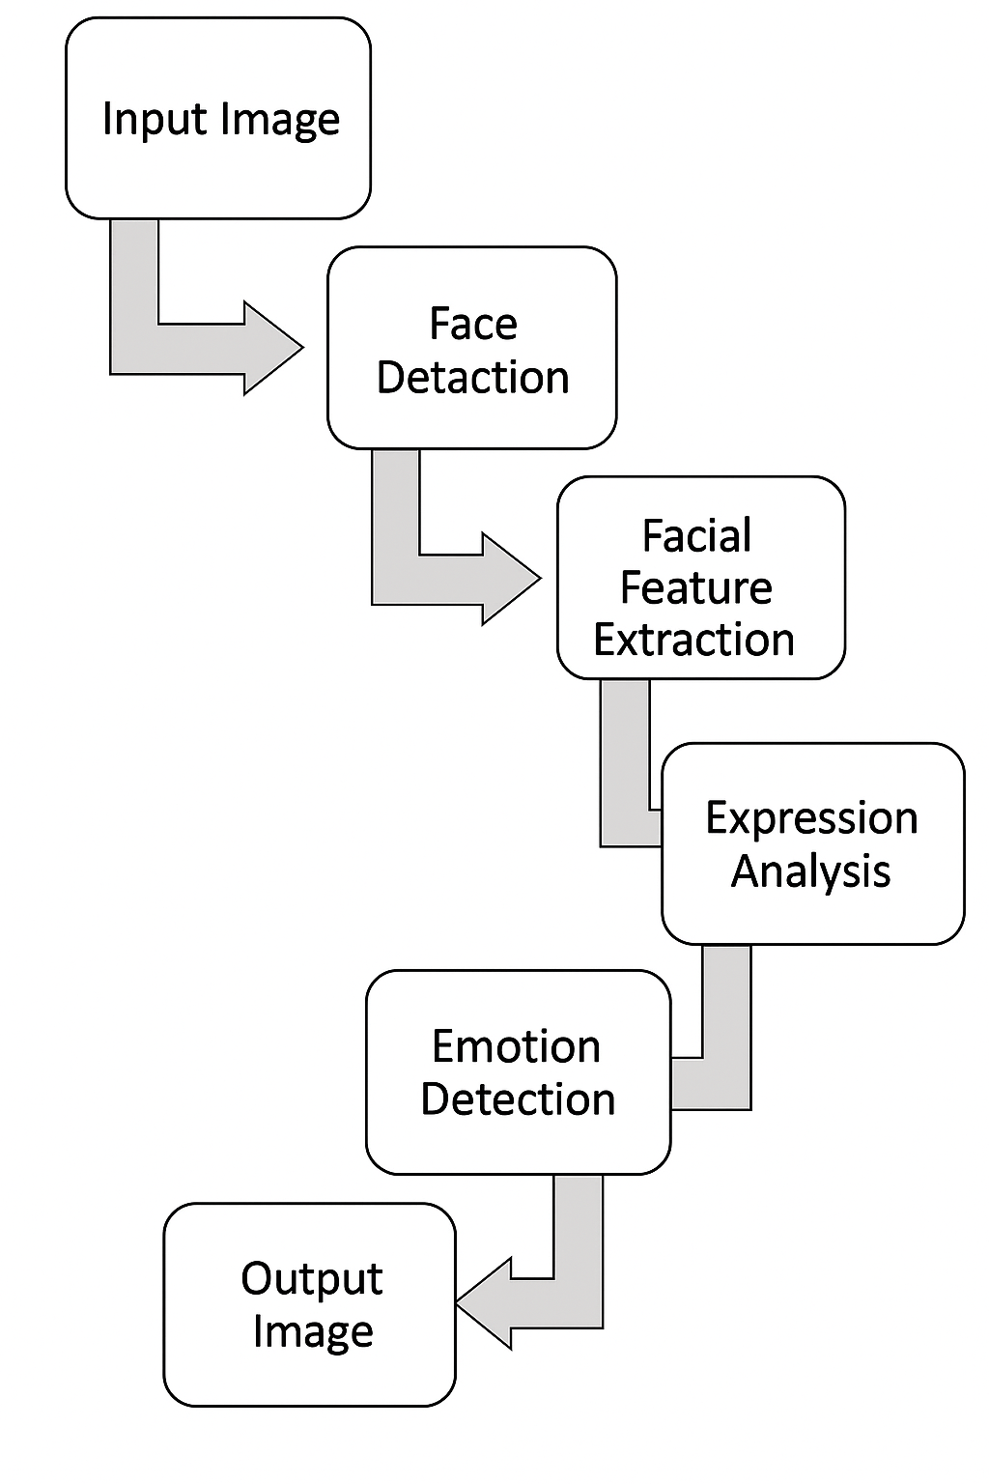

Figure 8.2.1: Block-diagram-of-Face-and-Emotion-detection-system

**8.3 PLACE :- ZENODO, BHILAI, DURG, CHHATTISGARH**

**8.4 PUBLISHED DATE :- 05 MAY 2025**